Automatic Form Fill & Seal Machine (FFS)
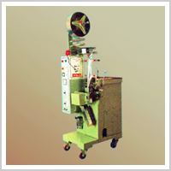MODEL : - HT – 015
Conducts Integrated Operations from measuring bag making filling & cutting To packaging with a Photocell Apparatus for packing Granules, Tea, Powder, Detergent Powder ,Coffee, Spices, Pan Masala, Milk Powder, Sugar, Salt, Supari, Pharmaceuticals, Etc.
Features : Convenient & Hygenic Form Of Packaging, Increased Shelf Life, Better Shelf Appeal, Increased Production, Low Waste Disposal, Unit Use Of Packing, Reduces Shipment Cost, Machine Simple & Easy To Operate, Easy To Change For Diffrent Pouch Sizes, Photocell Control System Can Automatically Adjust & Correct The Inaccuracy Of Printing Web Registration Eye Mark Within + -1.5mm.
Technical Specification : -
Sealing Type | :- |  | 3 Side / 4 Side / Center Sealing ( On Request ) .
 |  |  | 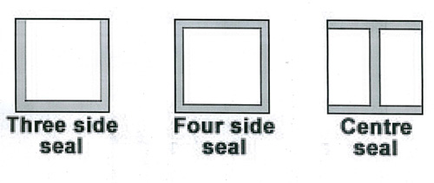
Packing Size | :- |  | L : 40 –120 mm or 100 –200 mm {Film Length }  W : 20 – 160 or 20 –220 mm { Film Width }.
Packing Range | :- |  | 0.5 – 20 Gms, 20 – 50 Gms, 50 –100 Gms, 100 – 300 Gms.  ( Depending On Specific Gravity Of Material To Be Packed ).
Speed | :- |  | 60 –120 Bag/ Min. , 45 –90 Bag/ Min.  ( Depending On Flow Rate Of the Material To Be Packed).
Packing Material | :- |  | Any Heat Sellable Laminated Film Such As Potvester / Polypaper/Paper/Polly/ Glassine/ Foil/ Polly Bopp Etc.
Motor | :- |  | ¼ H.P., 220 V A.C. / 50 Hz./ Single Phase.
Heater Load | :- |  | 4 Side Sealing , 3 Side Sealing & Center Seal.  150 W x 2 Nos., 300 W x 2 Nos.
Machine Dimensions | :- |  | 750X560X1750 { mm} [L X W X H]. (Approx. ).
Net Weight | :- |  | 360 Kilogram.
Optional | :- |  | Conding Device, Batch Cutting, Level Sensor Device, Fully S.S.Covering, Heater Indicator.

